**Name: Shreyash Milind Chilip Roll No: SEDA-41 Div: CS-D**

**ASSIGNMENT No: 02 Write an ALP for following operations on the string entered by the user.**

1. **Create Student record text file as “Student1” for given input student details.**
2. **Find out Btech student from “Student1” file and save the content into “Btech” file**



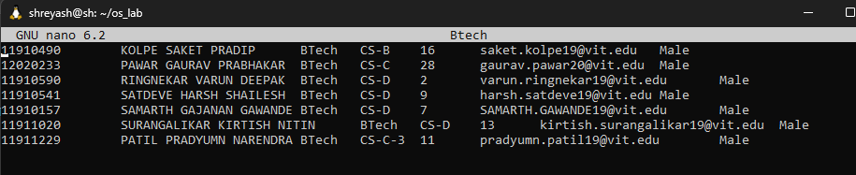

1. **Find out TY student from “Student1” file and save the content into “TY” file**



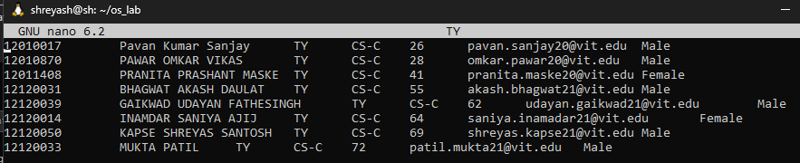

1. **Find out SY student from “Student1” file and save the content into “SY” file**



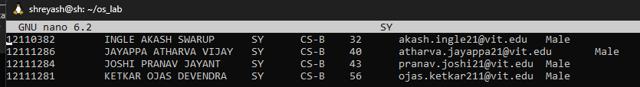

1. **Combine SY and TY students from “Student1” file and save the content into “SYTY” file**

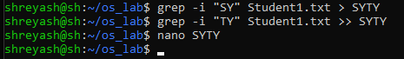

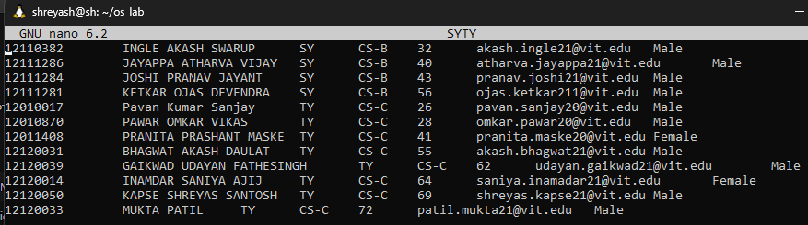

1. **Sort the file based on Roll No. and save content into “Student2” file.**



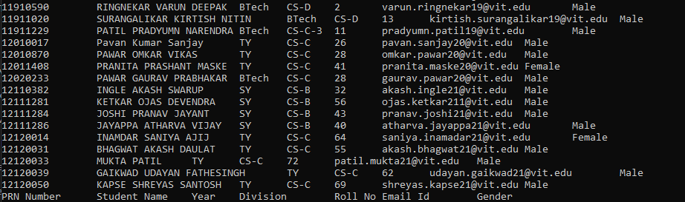

1. **Compare “Student1” file with “Btech” file and save content into “Student2” file.**



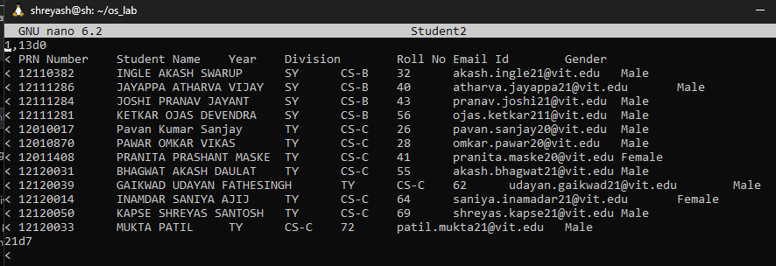

1. **Find out PRN NO, Student Name, Year and Division field data from “Student1” file.**



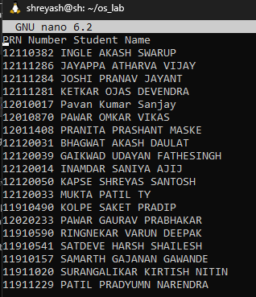

1. **Extract Roll No., Email Id, and Gender, save to Student4:**



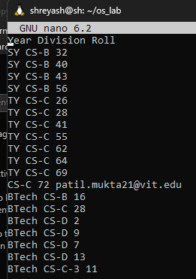

1. **Combine “Student3” and “Student4” file and save content into “Student5” file.**



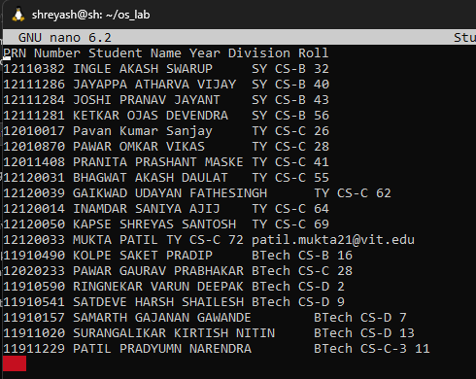

1. **Convert “Student1” content into Uppercase Letter and save into “Student6” file.**



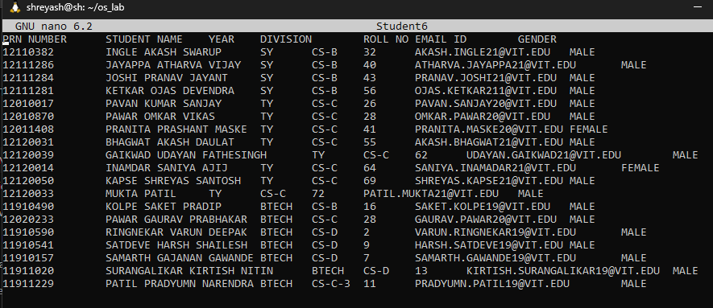

1. **Compare “Student1” and “BTech” file and save content into “Student7” file.**



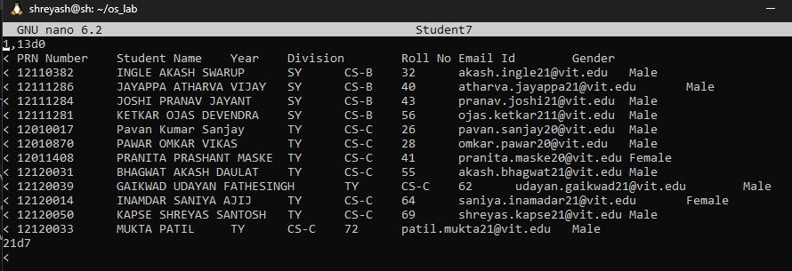

1. **Find out difference between “Student1” and “Btech” file and Save into “Student 8” file.**

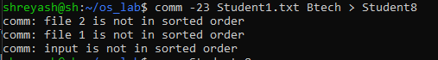

1. **Find out common between “Student1” and “Btech” file and save content into “Student9” file.**



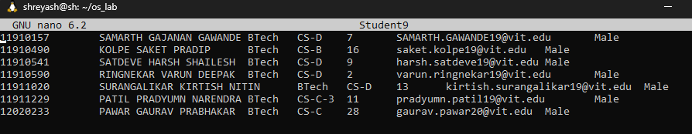

1. **Remove user and group of “SY” file read and write permission file.**



1. **Assign read, write, execute permission to user and others of “SY” file.**



1. **Display count of male students from “Student1” file.**



1. **Find out Name of student field data from “Student1” file and redirect output to count Number of students in “Student1” file.**



1. **Find out file and directory in current path and trap this output in userfile as “ufile”.Also Display count of number of directories and files in current path.**



